**AI Powered legal document assistant**

Mani Chourasiya Deepak Singh

Student Student

Department of AI&DS Department of AI&DS

Prestige Institute of Engineering Management and Research Prestige Institute of Engineering Management and Research

Simran Pawar Aman Sharma

Student Student

Department of AI&DS Department of AI&DS

Prestige Institute of Engineering Management and Research Prestige Institute of Engineering Management and Research

Prof. Diksha Bharwa

Abstract

In the rapidly evolving legal landscape, the demand for efficiency, accuracy, and accessibility in legal documentation processes is ever-increasing. The AI Legal Document Assistant, designed to transform the legal profession by harnessing the power of artificial intelligence (AI).The AI Legal Document Assistant is a cutting-edge software application. It serves as a comprehensive tool for legal professionals, offering a wide range of functionalities, including document generation, legal research, predictive analysis, and more. This system's core objective is to streamline and enhance the legal documentation process, enabling lawyers, paralegals, and legal practitioners to be more productive and efficient in their wor

Keywords—

Document Generation. Legal Research, NLP, Data Privacy And Security, User Document Versioning, Legal Analytics, Voice and Chat Interface, ML for Predictive analysis, Compliance and Ethics ,Training and Updates Support for Multiple Jurisdictions

**INTRODUCTION**

The AI Legal Document Assistant, a fusion of advanced AI algorithms, Natural Language Processing (NLP) capabilities, and machine learning, stands as a testament to the power of technology to augment the legal landscape. It serves as a comprehensive legal aide, adeptly navigating the intricate world of legal documentation and research, and in doing so, liberates legal professionals from the shackles of time-consuming administrative tasks

.

**Literature Survey**

1. Introduction to AI-powered Legal Document Assistants (LDAs):

This section should provide a general introduction to AI-powered legal document assistants, explaining their purpose, potential benefits, and key functionalities.

2. Natural Language Processing (NLP) in Legal Documents:

Explore the role of NLP in analyzing and processing legal texts. Include works that discuss the use of NLP techniques like named entity recognition, sentiment analysis, and topic modeling.

3. Document Automation in Legal Practice:

Examine the automation of legal document creation, management, and assembly using AI. Discuss the efficiency gains and cost savings associated with document automation.

4. Contract Analysis and Review with AI:

Investigate how AI is utilized for contract analysis, review, and due diligence. Discuss the accuracy and speed improvements in contract analysis enabled by AI.

5. AI-Powered Legal Tech Startups and Commercial Solutions:

Survey the landscape of AI-powered legal tech startups and commercial solutions. Include information on prominent companies, their features, and successful use cases.

6. Ethical and Regulatory Considerations in AI for Legal Documents:

Explore ethical concerns and regulatory considerations related to the use of AI in the legal profession, such as issues of bias, data privacy, and transparency.

7. Case Studies and Practical Implementations:

Provide examples of real-world case studies where AI-powered LDAs have been successfully integrated into legal workflows. Include information on the challenges faced and benefits realized.

8. Academic Research on AI in Legal Documents:

Survey academic papers and research articles that explore AI applications in legal documents, such as legal text classification, case law analysis, and legal information retrieval.

9. Comparison of AI Models for Legal Document Analysis:

Compare various AI models and techniques used in legal document analysis. Discuss the pros and cons of rule-based systems, machine learning approaches, and deep learning models.

10. Challenges and Future Directions in AI for Legal Documents:

Investigate the challenges associated with AI in the legal domain, such as the need for high-quality training data and interpretability of AI decisions. Discuss the potential future directions for AI-powered LDAs.

11. User Acceptance and Adoption of AI in Legal Practice:

Explore how legal professionals perceive and adopt AI-powered LDAs. Include user studies and surveys that provide insights into user acceptance and potential barriers.

12. Impact of AI on the Legal Industry:

Discuss the broader impact of AI on the legal industry, including changes in the roles of legal professionals and the evolving legal tech landscape.

This literature survey should encompass a wide range of topics and provide a comprehensive overview of AI-powered legal document assistants, from their foundational concepts to their practical implementations and potential future directions. You can delve into each topic by examining relevant literature and research articles

**System Requirement**

The system requirements for an AI-powered legal document assistant can vary depending on the specific software or application you're using and the complexity of the AI models involved. However, here are some general system requirements to consider:

1. Hardware Requirements:

Processor: A multi-core CPU (e.g., Intel Core i5 or better) to handle AI computations efficiently.

Memory (RAM): At least 8GB of RAM is recommended for smoother performance, but more may be needed for large-scale document processing or complex AI models.

Storage: An SSD (Solid State Drive) is preferred for faster data access and retrieval. The amount of storage space required depends on the size of the document database and AI model data.

2. Operating System:

Most modern operating systems are supported, including Windows, macOS, and various Linux distributions.

3. Software Requirements:

AI Frameworks: If you're developing your AI model or integrating existing ones, you'll need the necessary AI frameworks such as TensorFlow, PyTorch, or spacy.

Programming Languages: Proficiency in programming languages like Python is essential for working with AI and NLP libraries.

Document Management Software: Depending on the application, you might need specialized document management software or database solutions.

Web Server (if web-based): If your AI assistant is web-based, you may need a web server like Apache or Nginx to host the application.

4. Graphics Processing Unit (GPU):

GPUs, especially those with CUDA support, can significantly speed up AI model training and inference. If you're developing AI models, consider a compatible GPU.

5. Internet Connection:

A stable internet connection is important, especially if your AI-powered legal document assistant relies on cloud-based services or databases.

6. Security and Compliance:

If handling sensitive legal documents, ensure that the system complies with relevant security and privacy regulations, such as encryption standards, access controls, and data retention policies.

7. Scalability:

Depending on the scale of your operations, consider a system that can be easily scaled to accommodate increased workloads and data.

8. User Interface:

If your AI assistant has a graphical user interface (GUI), ensure compatibility with the user's preferred operating system.

9. Compatibility with Legal Software:

If your AI-powered assistant needs to integrate with existing legal software, ensure compatibility and consider API requirements.

It's important to note that the specific system requirements can vary significantly depending on the complexity of the AI models, the size of the legal document database, and the volume of documents to be processed. Therefore, it's advisable to consult with the software or AI model provider for their specific requirements and recommendations. Additionally, the security and privacy considerations are of utmost importance when handling legal documents, so compliance with legal standards is crucial.

**System architecture**

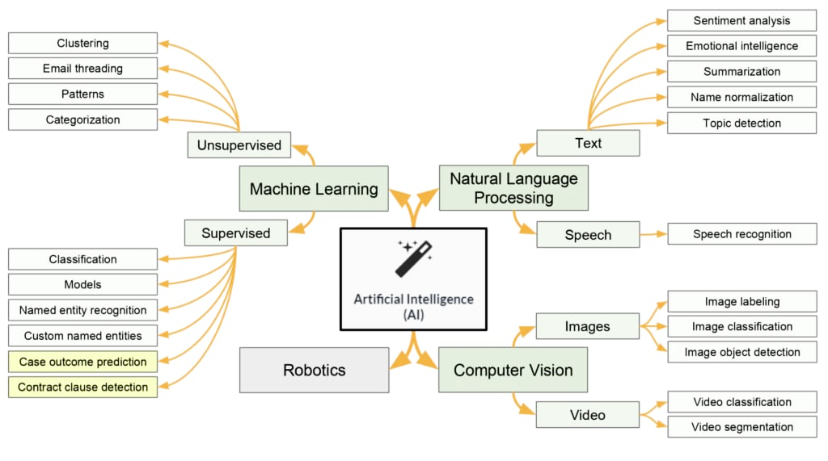

**Result and conclusion**

**Result**

**Efficiency and Time Savings**: AI-powered legal document assistants have been shown to significantly improve the efficiency of legal professionals by automating tasks such as document review, analysis, and generation. This has led to substantial time savings.

**Accuracy and Consistency**: AI-driven legal document analysis and review have demonstrated higher levels of accuracy and consistency compared to manual processes. These systems are less prone to human errors.

**Cost Reduction**: The use of AI in legal document tasks has the potential to reduce operational costs for law firms and legal departments. It allows them to handle more work with fewer resources.

**Improved Legal Research**: Legal professionals benefit from AI's ability to rapidly search and analyze extensive legal databases, making research faster and more comprehensive.

**Enhanced Document Management**: AI-powered assistants offer advanced document management features, enabling better organization, retrieval, and tracking of legal documents.

**Customization:** Some AI assistants allow for customization, enabling legal professionals to tailor the system to their specific needs and requirements.

**Scalability**: AI-powered legal document assistants can be scaled to handle larger volumes of documents and workloads, making them suitable for both small law firms and large corporate legal departments.

**conclusion**

**Efficiency**: They save time and streamline legal tasks.

**Accuracy:** They reduce errors and maintain consistency.

**Cost-Effective**: They lower operational costs.

**Enhanced Research**: They provide quick access to extensive legal data.

**Customizable and Scalable**: Tailored solutions for various needs.

These tools are transforming the legal profession, but ethical and security concerns must be addressed as they continue to evolve.